Monetary Policy – People’s Republic of China

Joseph Kim
Summer Associate
Merrill Lynch (FICC)
joseph_kim@ml.com

 | introduction | 2
 | FOREIGN EXCHANGE POLICY | 2 – 4
 | MONETARY POLICY TOOLS | 4 – 5
 | MONETARY POLICY – ISSUES AND CONSTRAINTS | 6 – 7
 | CONCLUSION | 7

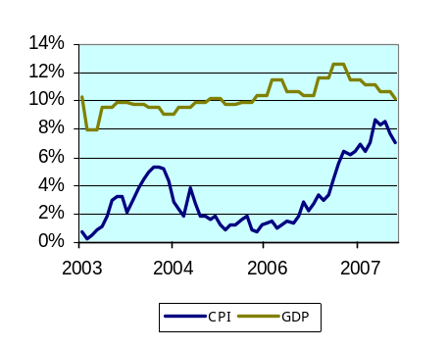  Exhibit 1: GDP vs CPI | INTRODUCTION  As China continues to gain prominence in the global economy, the People’s Bank of China (PBoC) faces the complex issue of controlling their money supply and currency value while maintaining balance between growth and inflation. China’s GDP has grown at a pace of 10-12% per annum over the last five years. However, the spread between GDP growth and inflation has been narrowing rapidly since 2007. The PBoC faces difficult challenges ahead given the monetary system’s predisposition towards excess liquidity.  This report will begin with a discussion on China’s foreign exchange policies followed by an overview of the various policy tools used by the PBoC. We will then shift our focus to gaining an understanding of the actual mechanism of those tools in the money market and the existing conditions that hinder the PBoC’s ability to effectively implement monetary policy.
Exhibit 2: Growth in trade surplus and FDI  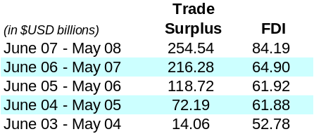  Exhibit 3: USD/CNY spot  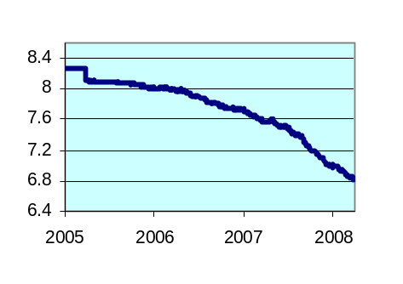  Exhibit 6 : CNY NDF outright levels  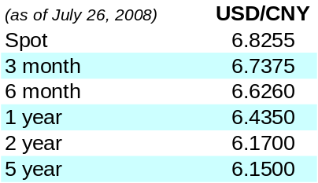  Exhibit 7: Pork prices  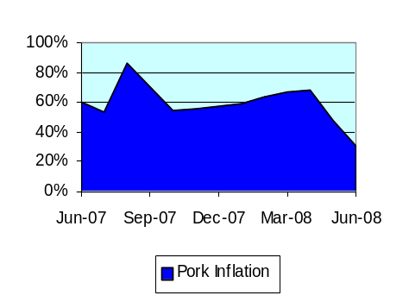 | FOREIGN EXCHANGE POLICY  Although several free market reforms have reshaped China’s economy over the past few decades, the state-run PBoC continues to actively manage the exchange rate of their currency, the renminbi (RMB), whose principal unit is the yuan (CNY). The government has kept the RMB undervalued via currency sterilization in an effort to stimulate output and keep employment at high levels in an export driven economy.  From the end of 1997 until mid 2005, RMB was pegged to USD with an extremely tight band around USD/CNY 8.28. As a result, current account balances were vastly improved and Chinese exports became increasingly competitive in the global marketplace. However, the Chinese government came under tremendous political pressure to remove the currency peg and eventually changed their policy in July 2005. The policy revision appreciated the yuan 2.1% against the dollar and now fixes against an  undisclosed basket of currencies. RMB trades within a band to the basket of 0.5% per day which can lead to large fluctuations over time as we have seen in the USD/CNY rate over the last few years (see exhibit 3).  To illustrate the sterilization process, assume a US counterpart in the diagram below. Chinese exporters receive USD in exchange for goods. The exporters then exchange USD for CNY at commercial banks, who in turn, exchange USD for CNY at the central bank all at the fixed or managed exchange rate. As China’s capital inflows are greater than outflows (see exhibit 2), the result is a growth in the monetary base since demand for RMB outpaces demand for USD.  Exhibit 4: Currency flow diagram  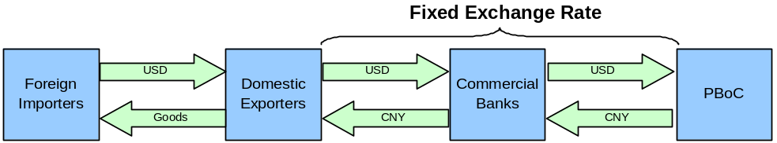  The second step is sterilization of the capital inflows by contracting the monetary base. The PBoC accomplishes this by buying back the local currency into foreign exchange reserve and issuing central banking bills.  Exhibit 5: Sterilization diagram    Note that the sterilization process has significant costs and risks. Interest must be paid on the PBoC bills which can turn out to be very expensive especially if interest rates need to be raised to cool the economy. The central bank typically takes cash from the foreign exchange reserve  (currently $1.8trn USD) and invests into longer-term assets to offset the interest expense on the issued bills, creating significant investment risks. The central bank also holds the risk of yuan depreciation and losing the ability to manage the exchange rate in case the balance of capital flows is reversed and reserves are depleted (although this scenario is unlikely given the large reserve balance noted above).  The country also faces other sources of monetary growth and inflation. Given the demand for capital to fund projects in China, loan growth can cause exponential increases in the money supply. Also, the widely held view that the PBoC must continue to appreciate the renminbi (exhibit 6) has led to speculative inflows of cash known as “hot money”, exacerbating growth in the monetary base. Inflation in China is also especially prone to supply shocks in food prices. For example, pork prices have been growing at an average of 59% inflation over the last twelve months (exhibit 7) as a result of “blue ear” pig disease.
Exhibit 8: Required Reserve Ratio  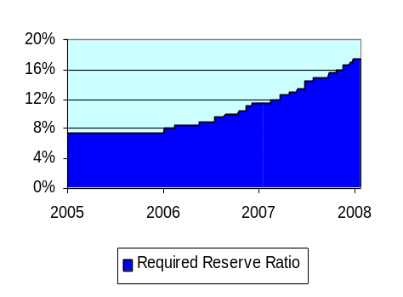  Exhibit 9: Deposit & loan growth (in trillions)  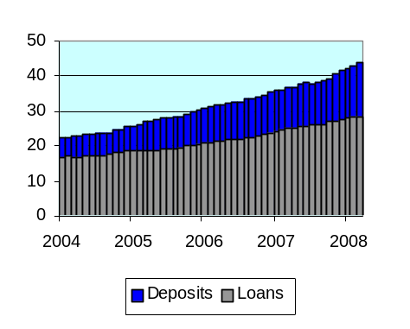 | MONETARY POLICY TOOLS  In conjunction with the open market operations described in the previous section, the PBoC primarily relies on a number of tools to accomplish their stated objective of maintaining stability in the value of the RMB thereby promoting economic growth.  Policy Rates and Lending Regulations  The PBoC regulates commercial banking activity by setting deposit and lending rates and guidelines. The rates are published for various maturities and are the main policy rates of the central bank. Lending rates are the minimum rates that may be given on a loan to a borrower and deposit rates are the maximum rates that can be paid on a deposit. Hence, the policy lending rate acts as a floor and the policy deposit rate acts as a cap to induce changes in the money supply.  Required Reserve Ratio (RRR)  All banks operating in China are required to hold a percentage of their deposits on reserve with the PBoC. This has the effect of withdrawing money from the monetary base by reducing the loan money multiplier. The required amount on reserve and any excess amounts in reserve are paid interest at rates determined by the central bank. Currently, the RRR is 17.50% and interest paid on required reserves and excess reserves are 1.89% and 0.99%, respectively. Banks deemed to hold significant loan default risk and/or low capital adequacy ratios have increased required reserve ratios of 0.5%.  Moral Suasion (Administrative Guidance)  Since the late nineties, the PBoC has shifted its intentions towards establishing a system of indirect control in banking sector. However, the central bank still resorts to administrative guidance when other policy tools prove to be ineffective or inefficient. Officially, guidance is sector related; ordering banks to lend less to certain industries such as real estate and more to agricultural and small businesses. Full details of guidance are not always freely disclosed and the effects can be difficult to quantify. It is widely suspected that the PBoC is implementing lending volume guidelines given the growth in deposits and corresponding loan growth over the past few years (exhibit 9).  Central Bank Lending  Although central bank lending was a key channel for expanding the monetary base until the mid-nineties, this tool has now evolved into a loan facility only used by troubled financial institutions. Also, since the foreign exchange regime has led to excess liquidity, central bank lending has lost importance and no longer plays a significant role in monetary policy.
Exhibit 10: PBoC Bill Issuance  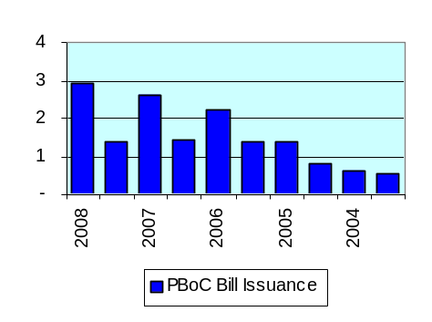 | MONETARY POLICY – ISSUES AND CONSTRAINTS  In the current environment, an overheating economy and inflation are the main concern of the PBoC. Several issues exist in the current policy framework, limiting the central bank’s ability to effectively control the monetary base.  Sustainability of the Foreign Exchange Regime  The large trade surplus combined with the large amount of FDI and hot money flows are creating a large operational challenge for the PBoC. Central bank issuance has increased substantially over the past few years as seen in exhibit 10 (half-year fluctuations are the result of seasonal spending around the Chinese New Year). The current system can be incredibly expensive and will eventually become unsustainable if bill issuance continues to grow at a feverish pace and interest payments continue to increase. Further, the current foreign exchange policy causes a divide between rate policy and money growth since higher rates would attract even more foreign capital inflows.  Interest Rate Transmission  There is a weak correlation between policy rates and the monetary base because of the low impact that policy rates have on lending behavior. Poor interest rate transmission is due to a number of reasons.  - Lending constraints and specific administrative guidance confine lending behavior, reducing the effect of policy rate transmission  - High levels of excess reserves (caused by lending constraints and exacerbated by FX inflows) in the banking system cause low demand for funding in the money market and insensitivity to interest rates fluctuations  - An underdeveloped money market focusing on transactions of seven days or less and small number of market participants causes rate instability.  - Central bank bill issuance and yields do have an effect on interbank rates. However, interbank rates have little effect on actual lending rates given the conditions above.  - Many corporations are insensitive to interest rates because they receive business loans from regional governments. Also, corporate bond issuances are restricted in terms of their issuance size and interest rate. This dilutes policy rate effectiveness throughout the broader economy.  Banking sector competitiveness  Chinese bank profitability is significantly handicapped by PBoC regulation. Commercial banks are restricted by minimum lending rates and are also restricted as to who they are allowed to lend to through administrative guidance. The low rate that banks receive on their reserve requirements (currently 1.89%) and the fact that the required reserve ratio is typically higher for Chinese banks than that of overseas banks hinders international competitiveness.
CONCLUSION
The evolution towards free market principles in China’s monetary system presents difficult challenges for the PBoC. A free-floating currency and the implementation of effective, indirect policies are distant goals. However, the central bank must continue to progress towards an independent monetary system to effectively manage the economy and support the competitiveness of China’s financial institutions.

